Modern Space Telescopes
  - Seeing the Invisible Universe
Sarah Hatfield, PhD

Chapter One: The Golden Eye
On the morning of December 25, 2021, an Ariane 5 rocket rose off the pad at Europe's spaceport in Kourou, French Guiana, carrying the most expensive scientific instrument ever launched into space. Folded inside its fairing, wrapped like origami, was the James Webb Space Telescope: twenty-five years of engineering, roughly ten billion dollars of investment, and the collected hopes of an entire generation of astronomers.
Nothing about the moment was routine. Unlike the Hubble Space Telescope, which orbits a few hundred miles overhead where a space shuttle crew could reach it, Webb was headed a million miles from Earth, far beyond any possibility of repair. If a single critical deployment failed, there would be no rescue mission. NASA engineers counted 344 single points of failure in the deployment sequence. Every one of them had to work.
Every one of them did.

A Deadline Twenty-Five Years in the Making
The idea that became Webb predates its own name. In 1996, three years before Hubble's most famous images were taken, a NASA committee recommended building a large, infrared-optimized successor then called simply the Next Generation Space Telescope. In 2002 it was renamed for James E. Webb, the administrator who steered NASA through the Apollo era, and the project settled into the long, difficult work of inventing technologies that did not yet exist.
Ten major innovations had to be developed from scratch, from microshutter arrays the width of a human hair to a sunshield membrane that could survive twenty-five years of micrometeorite weather. The budget grew, the schedule slipped, and Congress twice came close to cancellation. What saved the program, in the end, was the same argument that started it: there are questions about the early universe that simply cannot be answered any other way.
The project became a three-way partnership: NASA leading, the European Space Agency providing the launch and two instruments, and the Canadian Space Agency contributing the fine-guidance system. Northrop Grumman built the spacecraft and its remarkable sunshield; the Space Telescope Science Institute in Baltimore now operates the observatory for scientists around the world.

The Mirror That Had to Fold
A telescope's power begins with the size of its primary mirror, and Webb's is a monument: 6.5 meters across, nearly three times Hubble's diameter, with more than five and a half times the light-collecting area. No rocket fairing on Earth could carry a rigid mirror that size, so Webb's engineers did something no flagship observatory had attempted. They built the mirror in eighteen hexagonal segments and folded it, like a drop-leaf table, to fit inside the rocket.
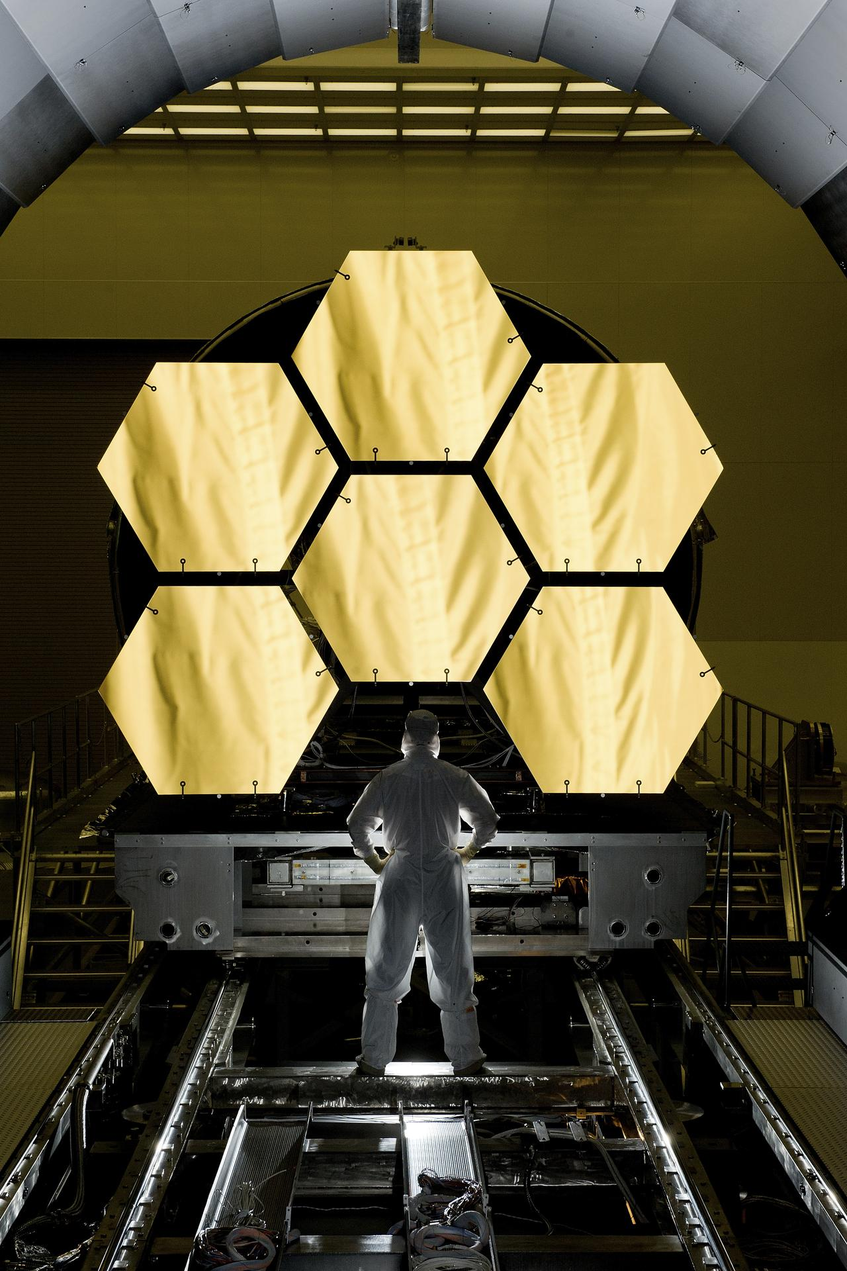
Figure 1. An engineer stands before six of Webb's gold-coated primary mirror segments during testing at NASA's Marshall Space Flight Center. (NASA)

Why Beryllium and Gold
Each segment is machined from beryllium, a metal chosen because it holds its precise shape across brutal temperature swings and weighs remarkably little; the entire eighteen-segment mirror masses less than Hubble's single slab of glass. Each segment then receives a whisper of gold, about 48 grams across the whole telescope, roughly the mass of a golf ball. Gold is not decoration: it reflects infrared light better than any practical alternative, turning the telescope's face into a perfect mirror for the wavelengths Webb was born to see.
Behind every segment sit seven actuators that can flex and tilt the surface in steps measured in billionths of a meter, letting engineers focus eighteen mirrors into one. When the alignment campaign finished in March 2022, the combined mirror performed better than the mission's most optimistic requirement.
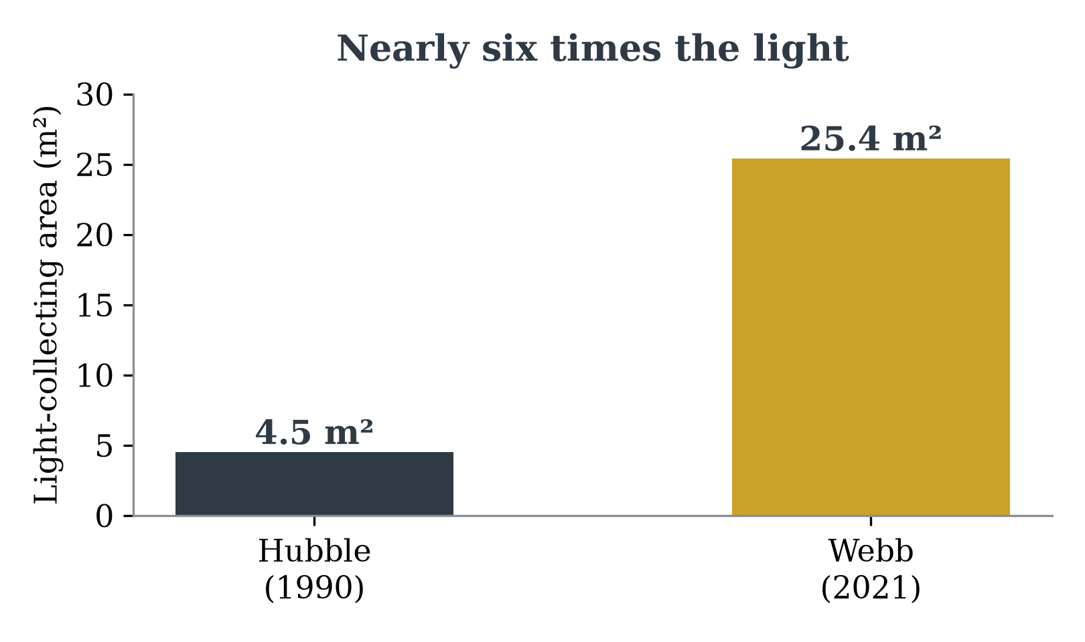
Figure 2. Webb's segmented primary collects nearly six times the light of Hubble's mirror — the difference between seeing a galaxy and reading its spectrum.

Cold Enough to See the Dawn
Webb is an infrared telescope, and infrared astronomy has a merciless enemy: heat. A warm telescope glows at exactly the wavelengths it is trying to observe, like trying to stargaze with a flashlight taped to your forehead. So Webb flies in permanent shadow behind a sunshield the size of a tennis court: five layers of aluminized Kapton, each thinner than a human hair, separated so that heat radiates away between them.
The result is one of the steepest temperature gradients in engineering. The sun-facing side of the shield bakes at about 85 degrees Celsius; the telescope side rests near minus 233. The mid-infrared instrument goes further still, chilled by its own cryocooler to about seven degrees above absolute zero. At that temperature, the telescope itself falls silent, and the faint warmth of the first galaxies can finally be heard.
WHY INFRARED?
The universe is expanding, and light from the earliest galaxies has been stretched along with it. Ultraviolet and visible light emitted 13 billion years ago arrives today as infrared. A telescope that wants to see the first galaxies has no choice about its wavelength; it must see heat. Infrared also slips through cosmic dust that blocks visible light, unveiling the stellar nurseries where stars and planets are born.

Four Instruments, One Sharp Eye
Behind the mirror, Webb carries four science instruments, each a small miracle of cryogenic engineering. Together they cover the spectrum from the red edge of human vision to the deep mid-infrared, and they can photograph, take spectra, block the glare of stars to reveal their planets, and split light from a hundred galaxies at once.
Instrument | Wavelengths | What it does
NIRCam | 0.6–5.0 µm | Webb's primary camera; took the deep-field images
NIRSpec | 0.6–5.3 µm | Spectroscopy of up to ~100 objects at once via a quarter-million microshutters
MIRI | 4.9–28.8 µm | Mid-infrared camera and spectrograph; sees cool dust and young planets
FGS/NIRISS | 0.8–5.0 µm | Fine guidance plus slitless spectroscopy of exoplanet atmospheres
Table 1. Webb's four science instruments. ESA contributed NIRSpec and half of MIRI; Canada built FGS/NIRISS.

The First Images
On July 11, 2022, the White House released a single photograph: a patch of sky the apparent size of a grain of sand held at arm's length, crowded with thousands of galaxies. Webb's First Deep Field, centered on the cluster SMACS 0723, took less than a day of observing time. Hubble's comparable deep fields had taken weeks.
The next morning brought the rest: the spectrum of water vapor in the atmosphere of the exoplanet WASP-96b; the death-shroud of a dying star in the Southern Ring Nebula; the compact dance of Stephan's Quintet; and the image that ended up on posters everywhere, the Cosmic Cliffs of the Carina Nebula, a coastline of dust and starlight seven light-years tall.
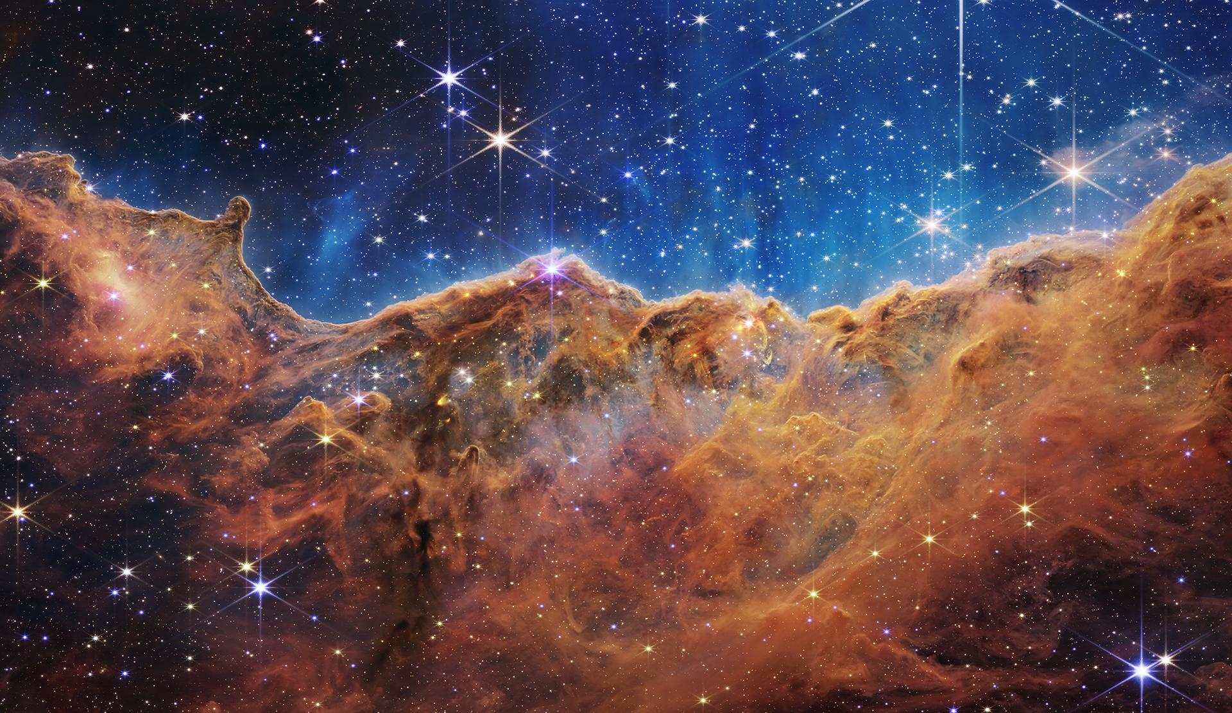
Figure 3. The Cosmic Cliffs at the edge of the Carina Nebula's star-forming region NGC 3324, imaged by Webb's NIRCam. Hundreds of previously hidden newborn stars pierce the dust. (NASA, ESA, CSA, STScI)
We are made of star-stuff, Carl Sagan liked to say. Webb's first year showed us the factories.

Rewriting the Timeline of Galaxies
Webb's deepest surprise came from its deepest images. Cosmologists expected the telescope to find infant galaxies in the universe's first billion years: small, faint, and few. Instead, programs like JADES and CEERS found galaxies earlier, brighter, and more mature than the models predicted, and they kept finding them earlier still.
In 2024, spectroscopy confirmed JADES-GS-z14-0 at a redshift of 14.3: a galaxy shining just 290 million years after the Big Bang, already holding hundreds of millions of suns. For comparison, the record Hubble spent three decades reaching, the galaxy GN-z11, dates to about 400 million years. Webb broke that record within months of opening its eye, and it has not stopped.
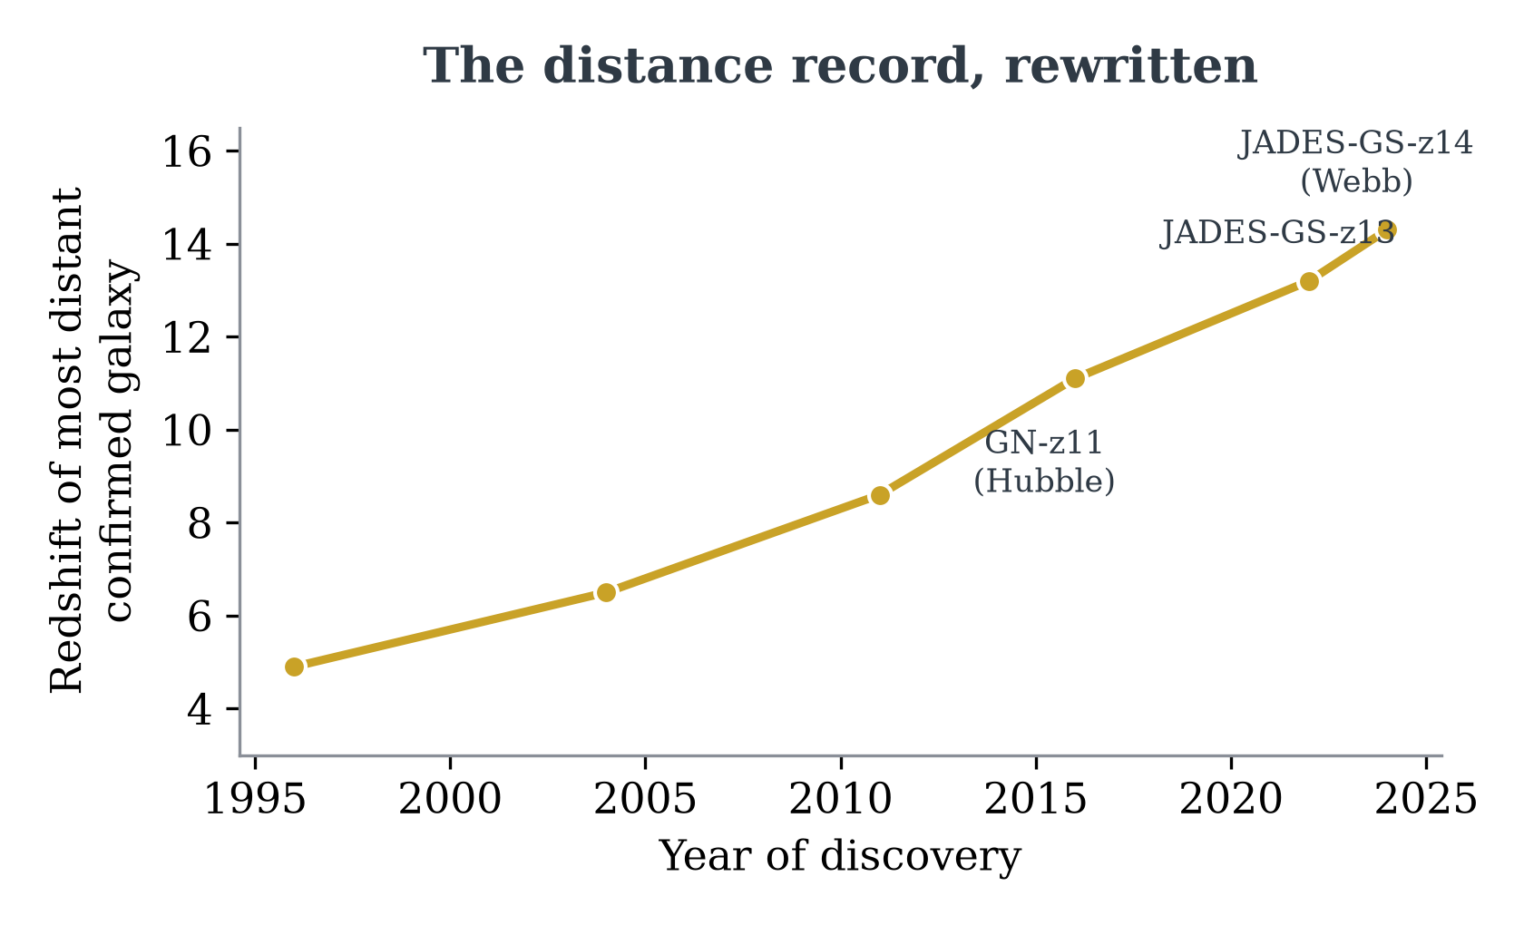
Figure 4. The most distant confirmed galaxy, by year of discovery. Redshift measures how much the expanding universe has stretched a galaxy's light — higher means earlier.

Webb and Hubble, Side by Side
The two observatories are usually framed as rivals, but they are better understood as complements: Hubble sees the ultraviolet and visible universe Webb cannot, and Webb reaches infrared depths forever beyond Hubble. For a decade, if we are lucky, astronomy gets to keep both.
 | Hubble | Webb
Launched | April 1990 | December 2021
Primary mirror | 2.4 m, single glass | 6.5 m, 18 beryllium segments
Collecting area | 4.5 m² | 25.4 m²
Wavelengths | 0.1–2.5 µm (UV–near-IR) | 0.6–28.8 µm (orange–mid-IR)
Orbit | Low Earth orbit, 540 km | Sun–Earth L2, 1.5M km
Serviceable | Yes — five shuttle missions | No
Operating temp. | About 20 °C | About −233 °C
Table 2. Two flagships, one sky: Hubble and Webb compared.

How a Deep Field Gets Made
Webb's most profound images are also its most patient. A deep field is less a photograph than a campaign:
- Choose a keyhole. Scientists select a patch of sky nearly empty of bright foreground stars, often one already mapped by Hubble so the two eras can be compared.
- Stare. The telescope returns to the same field for hours or days, letting photons that left their galaxies 13 billion years ago accumulate one by one.
- Stack and clean. Hundreds of exposures are aligned to a fraction of a pixel, cosmic-ray strikes are voted out, and the images are combined.
- Follow up with spectra. NIRSpec's microshutters open tiny doors on the most promising smudges, spreading each one into a spectrum that reveals its true distance.
- Confirm and publish. Candidate records only count once spectroscopy confirms the redshift — the step that separated JADES-GS-z14-0 from a decade of near-misses.

What Comes Next
Webb was built for a five-year primary mission, but its launch was so precise that the observatory kept most of its station-keeping fuel; engineers now talk comfortably about twenty years or more. Behind it, the Nancy Grace Roman Space Telescope is scheduled to launch later this decade with a field of view a hundred times wider, and NASA's planned Habitable Worlds Observatory aims at the question Webb was never quite designed to close: whether any of the small, rocky worlds it has glimpsed actually carry the chemical fingerprints of life.
Every era of astronomy has an instrument that defines it: Galileo's tube, the Hooker telescope that found other galaxies, Hubble itself. Ours unfolded, one golden hexagon at a time, a million miles from home — and it is just getting started.

Webb's final development cost is generally cited as $9.7 billion over 24 years, with roughly $861 million budgeted for its first five years of operations.
Webb orbits the second Sun-Earth Lagrange point (L2), a gravitational balance point about 1.5 million kilometers from Earth — roughly four times the distance to the Moon — where the Sun and Earth stay conveniently in one direction so a single shield can block them both.

